 |  |  |  |  |  | - |  |  | -

NAMA ………………………….…………………….. TINGKATAN ………………..……..

MODUL PINTAS 2021
TINGKATAN 5 4531/2

PHYSICS
Kertas 2
Ogos / Sept.

2 ½ jam Dua jam tiga puluh minit

JANGAN BUKA KERTAS SOALAN INI SEHINGGA DIBERITAHU

- Tulis nama dan tingkatan anda pada bahagian yang disediakan.
- Kertas soalan ini adalah dalam dwibahasa.
- Soalan dalam bahasa Melayu mendahului soalan yang sepadan dalam bahasa Inggeris.
- Calon dibenarkan menjawab keseluruhan atau sebahagian soalan sama ada dalam bahasa Inggeris atau bahasa Melayu.
- Calon dikehendaki membaca maklumat di halaman sebelah kertas soalan ini.
Untuk Kegunaan Pemeriksa
Bahagian | Soalan | Markah  Penuh | Markah Diperoleh
A | 1 | 4
A | 2 | 5
A | 3 | 6
A | 4 | 9
A | 5 | 9
A | 6 | 9
A | 7 | 9
A | 8 | 9
B | 9 | 20
B | 10 | 20
C | 11 | 20
Jumlah

Kertas peperiksaan ini mengandungi <<X>> halaman bercetak dan <<X>> halaman tidak bercetak
Maklumat berikut mungkin berfaedah. Simbol-simbol mempunyai makna yang biasa.
The following information may be useful. The symbols have their usual meaning.

1. | a = | 15 | $$λ=\frac{\text{ax}}{D}$$
2. | v² = u² + 2as | 16 | $$\frac{1}{f}=\frac{1}{u}+\frac{1}{v}$$
3 | s = ut + at² | 17 | n₁ sin Ө₁ = n₂ sin Ө₂
4 | W = mg | 18 | n = 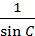
5 | F = ma | 19 | Daya apungan / Buoyant forve  F = ρ V g
6 | Daya graviti / Gravitational force | 20 | V = IR
7 | Daya memusat / Centripetal force | 21 | Kuasa / Power  P = VI
8 | Tempoh orbit / Orbital period | 22 | R = R₁ + R ₂  = +
9 | Halaju lepas/ Escape velocity, | 23 | 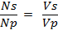
10 |  | 24 | Kecekapan .  Efficiency =
11 | Haba / Heat, Q = mc∆θ | 25 | Tenaga foton / Photon energy  E = h f
12 | Haba / Heat, Q = m l | 26 | Pemalar graviti/ Gravitational constant
13 | v = f λ | 27 | g = 9.81 m s⁻²
14 | T = | 28

Bahagian A
Section A
[60 markah]
[60 marks]
Jawab semua soalan dalam bahagian ini.
Answer all questions in this section.

For Examiner’s Use | 1 | Diberi satu persamaan yang menghubungkan tenaga foton, E, laju cahaya, c dan jarak gelombang cahaya, λ  Given an equation relating the photon energy, E, speed of light, c, and wavelength of light, λ  E = h
1(a)  1 |  | (a) | Apakah maksud jarak gelombang?.  What is the meaning of wavelength?  ................................................................................................................  [1 markah]  [1 mark]
1(b)  1 |  | (b) | Lengkapkan ayat berikut dengan menandakan (√ ) jawapan yang betul..  Complete the following sentence by ticking ( √ ) the correct answer.  Simbol h mewakili  Symbol h represent  pemalar De Broglie  De Brogle constant  pemalar Planck  Plank constant  [1 markah]  [1 mark]
1(c)  1 |  | (c) | Apakah unit S.I. bagi h ?  What is the S.I. unit of h ?  ................................................................................................................  [1 markah]  [1 mark]

 | (d) | Apakah yang berlaku kepada tenaga foton, E jika jarak gelombang cahaya, λ bertambah  What will happen to the photon energy, E if wavelength of light, λ increases  .............................................................................................................  [1 markah]  [1 mark] | For Examiner’s Use  1(d)  1  Total  A1  4

For Examiner’s Use | 2 | Rajah 2 menunjukkan daya graviti, F yang bertindak pada seorang budak lelaki dan perempuan masing-masing berjisim 70 kg dan 53 kg yang dipisahkan pada jarak, r = 1.0 m.  Diagram 2 shows gravitational force, F acting on a boy and a girl of mass 70 kg and 53 kg respectively which separated at distance, r = 1.0 m.    r = 1.0 m  F  F  m₁ ₌ 70 kg  m₂ ₌ 53 kg  Rajah 2  Diagram 2
2(a)  1 |  | (a) | Apakah maksud daya graviti?.  What is the meaning of gravitational force.?  ................................................................................................................  [1 markah]  [1 mark]
2(b)(i)  1 |  | (b) | Daya graviti, F boleh dihitung dengan menggunakan formula:  Gravitational force, F can be calculated by using formula:  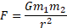  Dimana G adalah pemalar kegravitian  Where G is gravitational constant.  (i) Nyatakan unit F dalam sebutan unit-unit asas.  State the unit of F in terms of base unit.  ........................................................................................................  [1 markah]  [1 mark]

 | (b) | (ii) Hitung daya graviti, F.  Calculate the gravitational force, F.  [2 markah]  [2 marks] | For Examiner’s Use  2(b)(ii)  2
 | (c) | Mengapakah lelaki dan perempuan tersebut tidak merasai kesan daya graviti antara satu sama lain?  Why the boy and the girl did not experiences the effect of gravitational force toward each other?  .............................................................................................................  .............................................................................................................  [1 markah]  [1 mark] | 2(c)  1  Total  A2  5

For Examiner’s Use | 3 | Gelombang bunyi koheren dihasilkan oleh dua pembesar suara, S₁ dan S₂, yang dipisahkan oleh jarak 0.5 m seperti yang ditunjukkan pada Rajah 3.  Coherent sound waves are produced by two loudspeakers, S₁ and S₂, separated by a distance of 0.5 m as shown in Diagram 3.  Penjana isyarat  Signal generator  Pembesar suara  Loud speaker  Rajah 3  Diagram 3
3(a)(i)  1 |  | (a) | (i) Apakah maksud gelombang koheren?  What is the meaning of coherent waves?  ........................................................................................................  [1 markah]  [1 mark]
3(a)(ii)  2 |  |  | (ii) Nyatakan sama ada bunyi adalah gelombang melintang atau membujur.  Terangkan jawapan anda.  State whether sound is a transverse or a longitudinal wave. Explain your answer.  ........................................................................................................  ........................................................................................................  .......................................................................................................  [2 markah]  [2 marks]

 | (b) | Seorang murid berjalan perlahan-lahan di hadapan dan pada jarak  2.5 m dari dua pembesar suara. Pada Rajah 3, kedudukan-kedudukan di mana bunyi paling kuat didengar dilabel L dan bunyi paling lemah didengar dilabel S.  A student walks slowly in front of and 2.5 m away from the loudspeakers. In Diagram 3, the positions where very loud sounds are heard are labelled L and the positions where very soft sounds are heard labelled S.  (i) Nyatakan apa yang berlaku pada titik berlabel L.  State what happens at the points labelled L.  ...................................................................................................  ...................................................................................................  ...................................................................................................  [2 markah]  [2 marks] | 3(b)(i)  2
 |  | (ii) Jarak antara tiga bunyi kuat berturutan ialah 8.0 m. Hitungkan panjang gelombang bunyi itu.  The distance between three consecutive loud sounds is 8.0 m. Calculate the wavelength of the sound.  [2 markah]  [2 marks] | 3(b)(ii)  2  Total  A3  7

For Examiner’s Use |  |  |  |  | 4  Menara B  Tower B | Rajah 4 menunjukkan seorang akrobat berdiri tegak di atas seutas tali yang tegang. Akrobat itu mengalami keseimbangan daya.  Diagram 4 shows an acrobat stand still on a tight rope. The acrobat experiences equilibrium of forces.  Menara A  Tower A    27˚  50˚  T₂  Tali yang tegang  Tight rope  T₁  W  Rajah 4  Diagram 4  Jisim akrobat tersebut adalah 50 kg dan ketegangan tali, T₂ adalah 450 N. Kekuatan medan graviti adalah 9.81 N kg⁻¹  The mass of the acrobat is 50 kg and tension of rope, T₂ is 450 N. The gravitational field strength is 9.81 N kg⁻¹
4(a)  1 |  |  |  |  |  | (a) | Apakah maksud keseimbangan daya?  What is the meaning of equilibrium of forces?  ................................................................................................................  [1 markah]  [1 mark]
4(b)  2 |  |  |  |  |  | (b) | Apa yang patut dilakukan oleh acrobat tersebut supaya dia boleh mengekalkan keseimbangan semasa berjalan melalui tali tersebut. Jelaskan jawapan anda.  What should the acrobat do to maintain her balancing while walking through the rope. Explain your answer.  ................................................................................................................  ................................................................................................................  [2 markah]  [2 marks]
 |  | (c) |  | (i) Pada ruangan di bawah, lakarkan lukisan untuk menunjukkan segi tiga daya yang bertindak pada Rajah 4. Dalam lakaran anda, tandakan arah dan labelkan daya-daya dan sudut yang dipaparkan.  In the space below, sketch the diagram to show the triangle of forces acting on Diagram 4. In your sketch indicate the direction of forces, label all the forces and show the angles involved.  [3 markah]  [3 marks] |  |  |  | 4(c)(i)  3
 |  |  |  | (ii) Tentukan tegangan tali, T₁  Determine the tension of the rope, T₁  [3 markah]  [3 marks] |  |  |  | 4(c)(ii)  3  Total  A4  9
For Examiner’s Use |  |  |  |  | 5 | Rajah 5 menunjukkan bahagian- bahagian spektrum elektromagnet dengan panjang gelombang dan frekuensi masing-masing.  Diagram 5 shows the parts of the electromagnetic spectrum with their respective wavelengths and frequencies  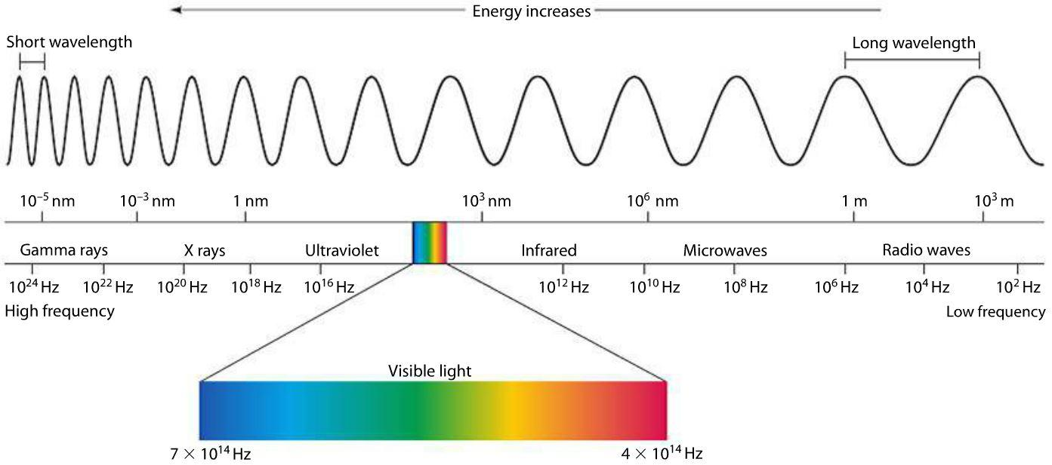  Tenaga bertambah  Energy increases  Gelombang radio  Radio waves  Y  Inframerah  Infrared  Ultraungu  Ultraviolet  Sinar X  X rays  Sinar γ  γ rays  Cahaya nampak  Visible light  Rajah 5  Diagram 5
5(a)  1 |  |  |  |  |  | (a) | Apakah maksud gelombang electromagnet?  What is the meaning of electromagnetic waves?  ................................................................................................................  [1 markah]  [1 mark]
5(b)(i)  1 |  |  |  |  |  | (b) | Berdasarkan Rajah 5, bandingkan  Based on Diagram 5, compare  (i) panjang gelombang bagi sinar γ dan gelombang radio  the wavelength of γ-rays and radio waves.  ........................................................................................................  [1 markah]  [1 mark]
(ii) frekuensi bagi sinar γ dan gelombang radio
the frequency of γ-rays and radio waves.

........................................................................................................
[1 markah]
[1 mark]
 |  |  | (iii) tenaga yang dibawa oleh sinar γ dan gelombang radio  the energy carried by γ-rays and radio waves.  ........................................................................................................  [1 markah]  [1 mark] |  |  |  |  |  | For Examiner’s Use  5(b)(iii)  1
 | (c) |  | Menggunakan jawapan anda di 5(b), nyatakan hubungan antara panjang gelombang dengan frekuensi gelombang elektromagnet.  Using your answers in 6(b), state the relationship between  wavelength and frequency  ................................................................................................................  [1 markah]  [1 mark] |  |  |  |  |  | 5(c)  1
 | (d) |  | Bandingkan halaju sinar γ dan gelombang radio  Compare the velocity of γ-rays and radio waves.  .  ................................................................................................................  [1 markah]  [1 mark] |  |  |  |  |  | 5(d)  1
 | (e) |  | Namakan satu kegunaan gelombang elektromanet pada kedudukan Y pada spektrum dalam Rajah 5.  Name one use for the electromagnetic wave at position Y on the spectrum in Diagram 5.  ................................................................................................................  [1 markah]  [1 mark] |  |  |  |  |  | 5(e)  1
 | (f) |  | Sebuah stesen televisyen memancarkan gelomban gradio berfrekuensi 2.5 × 10⁸ Hz. Hitung panjang gelombang radio yang dipancarkan oleh stesen televisyen ini.  A television station emits radio waves of frequency 2.5 × 10⁸ Hz. Calculate the wavelength of the waves emitted by this television station.  [2 markah]  [2 marks] |  |  |  |  |  | Total  A5  9  5(f)  2
For Examiner’s Use |  |  |  |  | 6 | Rajah 6.1(a) dan 6.2(a) menunjukkan dua susunan litar untuk mengkaji hubungan antara beza keupayaan dan arus bagi satu dawai konstantan yang berbeza ketebalannya.  Rajah 6.1(b) dan 6.2(b) menunjukkan graf beza keupayaan melawan arus yang sepadan bagi Rajah 6.1(a) dan 6.2(a) masing-masing. Kecerunan graf mewakili rintangan dawai konstantan itu.  Diagram 6.1(a) and 6.2(a) show two circuits used to investigate the relationship between potential difference and electric current of a constantan wire of different thickness.  Diagram 6.1(b) and 6.2(b) show the graph of potential difference against electric current for Diagram 6.1(a) and 6.2(a) respectively. The gradient of the graph represents the resistance of the constantan wire.  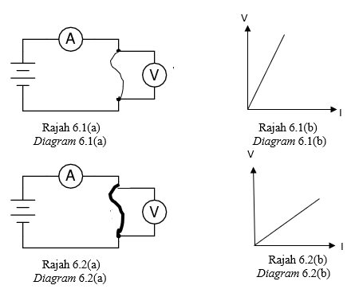
6(a)  1 |  |  |  |  |  | (a) | Apakah maksud rintangan?  What is the meaning of resistance?  ................................................................................................................  [1 markah]  [1 mark]

 | (b) | Berdasarkan Rajah 6.1 dan 6.2,  Based on Diagram 6.1 and 6.2,  (i) Bandingkan ketebalan dawai konstantan itu.  Compare the thickness of constantan wire.  ........................................................................................................  [1 markah]  [1 mark] | For Examiner’s Use  6(b)(i)  1
 |  | (ii) Bandingkan rintangan dawai konstantan itu.  Compare the resistance of constantan wire.  ........................................................................................................  [1 markah]  [1 mark] | 6(b)(ii)  1
 |  | (iii) Hubungkaitkan ketebalan dawai dengan rintangan.  Relate the thickness with the resistance.  ........................................................................................................  [1 markah]  [1 mark] | 6(b)(iii)  1
 | (c) | Rajah 6.3 menunjukkan tiga perintang X, Y dan Z masing-masing  20 Ω disambungkan ke sel kering, 6V.  Diagram 6.3 shows three resistors X, Y and Z of resistance 20 Ω respectively are connected to dry cell, 6V.  X  I  Z  Y  6V  Rajah 6.3  Diagram 6.3

For Examiner’s Use  6(c)(i)  2 |  |  |  | (c) | Berdasarkan Rajah 6.3,  Based on Diagram 6.3,  Hitungkan  Calculate  (i) Rintangan berkesan litar itu.  Effective resistance of the circuit.  [2 markah]  [2 marks]
6(c)(ii)  1 |  |  |  |  | (ii) Arus, I.  Current, I.  [1 markah]  [1 mark]
6(c)(iii)  1 |  |  |  |  | (iii) Kuasa yang dilesapkan pada X.  Power dissipated at resistor X.  [1 markah]  [1 mark]
Total  A6  9  6(d)  1 |  |  |  | (d) | Apakah yang akan berlaku kepada arus I jika perintang Z dikeluarkan?  What will happen to the current, I if resistor Z is removed?  ................................................................................................................  [1 markah]  [1 mark]
7 | Rajah 7.1 menunjukkan graf halaju-masa sebuah kereta yang menggunakan brek selepas bergerak dengan halaju malar, 10 m s ⁻¹.  Diagram 7.1 shows a velocity-time graph of a car which apply the brake after moving at constant velocity 10 m s ⁻¹.  Halaju / m s⁻¹  Velocity / m s⁻¹  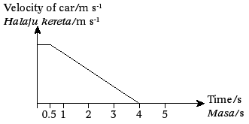  Masa/ s  Time/ s  10  Rajah 7.1  Diagram 7.1 |  |  |  |  | For Examiner’s Use
 | (a) | Nyatakan kuantiti fizik yang mewakili luas di bawah graf itu  State the physics quantity that represents the area under the graph.  ........................................................................................................  [1 markah]  [1 mark] |  |  |  | 7(a)  1
 | (b) | (i) Nyatakan jenis gerakan kereta itu selepas 0.5 s.  State the type of motion of the car after 0.5 s.  [1 markah]  [1 mark]  (ii) Hitungkan jumlah jarak yang dilalui oleh kereta itu.  Calculate the total distance travelled by the car.  [2 markah]  [2 marks] |  |  |  | 7(b)(i)  1  7(b)(ii)  2
For Examiner’s Use |  |  |  | (c) | Rajah 7.2 menunjukkan seorang sedang bermain golf.  Diagram 7.2 shows a man playing golf.  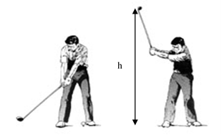  Rajah 7.1  Diagram 7.1  Jadual 1 menunjukkan jenis kayu golf dan ketinggian, h yang berbeza yang digunakan dalam permainan golf  Table 1 shows different type of golf club and height, h used in a golf game.  Jadual 1  Table 1  Cadangkan kaedah yang sesuai untuk menambah jarak pergerakan bola golf itu berdasarkan aspek- aspek berikut  Suggest the suitable method to increase the distance travelled by the ball based on the following aspects.
  Kaedah Method | Jenis kayu golf  Type of golf club | Ketinggian  Height, h (m)
  X | Fiber karbon  Carbon fibre | 1.5
  Y | Kayu  Wood | 2.0
  Z | Titanium | 2.5
7(c)(i)  2  7(b)(ii)  2 |  |  |  | (c) | (i) Jenis kayu golf  Type of golf club.  ........................................................................................................  Sebab  Reason  ........................................................................................................  [2 markah]  [2 marks]

 | (c) | (ii) Ketinggian  Height, h  ........................................................................................................  Sebab  Reason  ........................................................................................................  [2 markah]  [2 marks] | 7(c)(ii)  2
 | (d) | Berdasarkan jawapan anda dalam 7(c) pilih kaedah yang paling  sesuai digunakan dalam permainan golf itu  Based on your answers in 7(c) choose the most suitable method used in the golf game.  ................................................................................................................  [1 markah]  [1 mark] | 7(d)  1

For Examiner’s Use | 8 | Rajah 8.1 menunjukkan suatu magnet kekal dalam suatu dinamo basikal  sedang berputar pada laju tinggi.  Diagram 8.1 shows a permanent magnet inside a bicycle dynamo  rotating at high speed.  Magnet kekal  Permanent magnet  Gegelung lilitan  Turns of the coil  Mentol menyala  Bulb lights up  Putaran  Rotation  Rajah 8.1  Diagram 8.1
8(a)(i)  1 |  | (a) | (i) Nyatakan perubahan tenaga yang berlaku pada dinamo itu.  State the energy changes that takes place at the dynamo.  ........................................................................................................  [1 markah]  [1 mark]
8(a)(ii)  1 |  |  | (ii) Nyatakan konsep fizik yang terlibat.  State the physics concept involved.  ........................................................................................................  [1 markah]  [1 mark]

 | (b) | Rajah 8.2 menunjukkan seorang budak perempuan sedang mengayuh basikal pada waktu malam. Lampu basikalnya agak malap walaupun budak itu mengayuh basikalnya dengan laju.  Diagram 8.2 shows a girl cycling at night. The bicycle’s lamp a bit dim although the girl cycling faster.  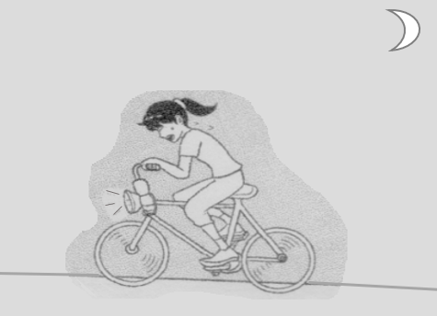  Malap  Dim  Rajah 8.2  Diagram 8.2  Nyatakan pengubahsuaian yang perlu dilakukan kepada dinamo  itu untuk menambah kecerahan mentol tersebut  State modification needs to be done to the dynamo to increase the  brightness of the bulb
 |  | (i) Magnet yang digunakan.  The magnet used.  ........................................................................................................  Sebab  Reason  ........................................................................................................  [2 markah]  [2 marks] |  |  |  | 7(b)(i)  2
 | (c) | (ii) Bilangan lilitan gegelung dawai.  The number of turns of the coil.  ........................................................................................................  Sebab  Reason  ........................................................................................................  [2 markah]  [2 marks] |  |  |  | 7(b)(ii)  2
For Examiner’s Use  8(b)(iii)  2 |  |  |  | (b) | (iii) Bahan yang sesuai untuk gegelung dawai.  Suitable material of coil wire.  ........................................................................................................  Sebab  Reason  ........................................................................................................  [2 markah]  [2 marks]
Total  A8  9 |  |  |  | (c) | Rajah 8.3 menunjukkan suatu arus diaruhkan apabila teras besi bentuk U digerakkan ke atas.  Diagram 8.3 shows a current induced when the U-shape iron core is moved upwards.  Konduktor pegun  Conductor at rest  Galvanometer  Galvanometer  Teras besi  Bergerak ke atas  Iron core  moves upwards  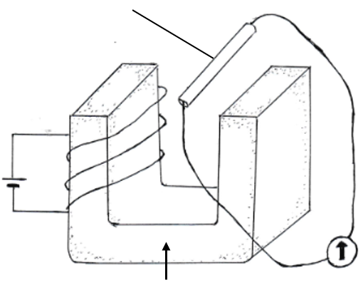  Diagram 8.3  Rajah 8.3  Tandakan pada Rajah 8.3 arah pergerakan arus mengalir pada konduktor.  Mark at Diagram 8.3 the direction of current flow in the conductor.  [1 markah]  [1 mark]
8(c)

1

Bahagian B
Section B
[20 markah]
[20 marks]
Jawab mana-mana satu soalan daripada bahagian ini.
Answer any one question from this section.

9  Penutup periuk dalaman  Cover for inner pot  Periuk luar  Outer pot  Periuk dalaman  Inner pot  Space S  Ruang S | Rajah 9 menunjukkan keratan rentas sebuah periuk terma.  Diagram 9 shows the cross-section of a thermal cooker.  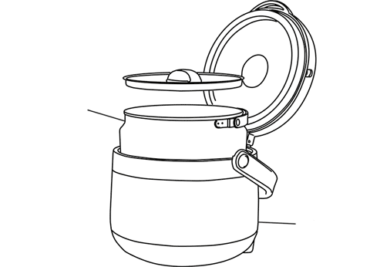  Rajah 9  Diagram 9
 | (a) | Apakah maksud haba?  What is the meaning of heat?  [1 markah]  [1 mark]
 | (b) | Huraikan bagaimana periuk terma berfungsi. Berikan 2 kebaikan menggunakan periuk terma.  Explain how the thermal cooker works. Give 2 advantages of using thermal cooker.  [4 markah]  [4 marks]
 | (c) | Jadual 2 menunjukkan ciri-ciri sebuah periuk terma.  Table 2 shows the characteristics of a thermal cooker.  Jadual 2  Table 2  Anda dikehendaki menentukan kessesuaian periuk terma untuk mengekalkan haba makanan untuk beberapa jam. Terangkan kesesuaian setiap spesifikasi. Pilih periuk terma yang paling sesuai dan beri sebab untuk pilihan anda.  You are required to determine the most suitable thermal cooker that can be used to keep the food warm for a few hours. Explain the suitability of each specification. Choose the most suitable thermal cooker and give reasons for your choice.  [10 markah]  [10 marks]
  Periuk terma  Thermal cooker | Bahan digunakan untuk periuk dalaman  Material used for the inner pot | Lapisan dalam periuk dalaman disalut dengan  Inner layer of inner pot coated with | Bahan digunakan untuk periuk luar  Material used for the outer pot | Ruang S  Space S
  P | Aluminium  Aluminium | Cat berkilat  Shiny paint | Besi  Iron | Vakum  Vacuum
  Q | Aluminium  Aluminium | Cat hitam  Black paint | Plastik  Plastic | Udara  Air
  R | Keluli tahan karat  Stainless steel | Cat berkilat  Shiny paint | Plastik  Plastic | Vakum  Vacuum
  S | Keluli tahan karat  Stainless steel | Cat hitam  Black paint | Besi  Iron | Udara  Air
 | (d) | 750 g ais pada suhu -3˚C diletakkan dalam gelas dan dibiarkan mencair pada suhu bilik 30˚C.  750 g of ice at -3 ˚C is put into a glass and left to melt to room temperature at 30 ˚C.  (i) Lakarkan graf suhu-masa bagi proses ais yang mencair itu.  Sketch the temperature-time graph for the process of the melting ice.  [2 markah]  [2 marks]
(ii) Hitungkan kuantiti haba yang diserap oleh ais yang mencair.
Haba pendam tentu pelakuran ais ialah 3.34 x10 ⁵ J kg⁻¹, muatan haba tentu air ialah 4200 J kg⁻¹ ˚C⁻¹ dan muatan haba tentu ais ialah 2100 J kg⁻¹ ˚C⁻¹)
Calculate the quantity of heat gain by the melting ice.
The latent heat of fusion of ice is 3.34 x10⁵ J kg⁻¹, the specific heat capacity
of water is 4200 J kg⁻¹˚C⁻¹ and the specific heat capacity of ice is
2100 J kg⁻¹˚C⁻¹

[3 markah]
[3 marks]

10  Neraca mampatan  Compression balance | Rajah 10.1(a) dan 10.1(b) menunjukkan radas yang digunakan oleh seorang murid dalam mengkaji suatu prinsip Fizik.  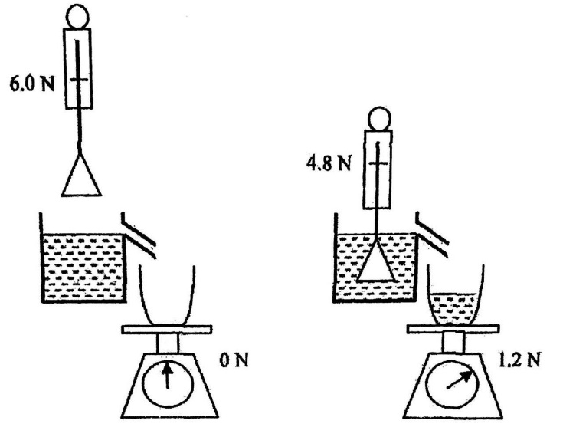  Diagram 10.1 and 10.1(b) shows the apparatus used by a student to study a physics principle.  Neraca spring  Spring balance  Objek  Object  Air yang tersesar  Water displaced  Rajah 10.1(a)  Diagram 10.1(a)  Rajah 10.1(b)  Diagram 10.1(b)  Rajah 10.1 (a) menunjukkan berat objek yang di ukur oleh sebuah neraca spring di udara adalah 6.0 N.  Rajah 10.1 (b) menunjukkan objek diturunkan sehingga terendam penuh dalam air. Beratnya di dalam air adalah 4.8 N. Berat air yang tersesar adalah 1.2 N.  Ketumpatan air adalah 1 x 10³ kg m⁻³.  Diagram 10.1 (a) shows that the weight of an object measured by a spring balance in air is 6.0 N.  Diagram 10.1 (b) shows the object being lowered until fully submerged in water. The weight of the object is water is 4.8 N.  The density of water is 1 x 10³ kg m⁻³.
 | (a) | Namakan prinsip fizik yang terlibat..  Name the physics principle involved..  [1 markah]  [1 mark]
 | (b) | Berdasarkan Rajah 10(a) dan (b)  Based on Diagrams 10(a) and (b):  (i) Berapakah daya apungan yang bertindak ke atas objek itu?  What is the buoyant force acting on the object?  [1 markah]  [1 mark]  (ii) Bandingkan daya apungan dengan berat air yang tersesar oleh objek tersebut.  Compare the buoyant force and weight of water displaced by the object.  [1 markah]  [1 mark]  (iii) Hitungkan isipadu objek.  Calculate the volume of the object.  [3 markah]  [3 marks]
 | (c) | 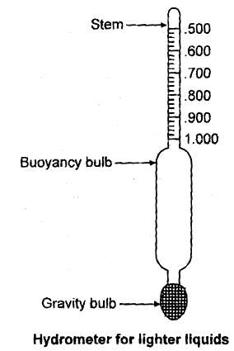  Batang berskala  Stem with scale  Bebola apungan  Bouyancy bulb  Ballast bulb  Bebola balast  Rajah 10.2  Diagram 10.2  Hidrometer adalah alat yang digunakan untuk mengukur ketumpatan relatif cecair berdasarkan konsep daya apungan seperti ditunjukkan dalam Rajah 10.2.  Ia terdiri daripada tiub kaca berongga dengan bebola apungan, bebola balast sebagai pemberat untuk kestabilan, dan batang sempit dengan skala untuk mengukur.  A hydrometer is an instrument used for measuring the relative density of liquids based on the concept of buoyancy as shown in Diagram 10.2.  It consists of a sealed hollow glass tube with a wider bulb for buoyancy, a ballast bulb as a weight for stability, and a narrow stem with a scale for measuring.  Jadual 3 menunjukkan ciri-ciri sebuah hydrometer.  Table 3 shows the characteristics of a hydrometer.  Jadual 3  Table 3  Terangkan kesesuaian setiap ciri yang disenaraikan dan tentukan hidrometer mana yang harus dipilih. Beri sebab untuk pilihan anda.  Explain the suitability of each characteristic listed and determine which hydrometer should be chosen. Give reasons for your choice.  [10 markah]  [10 marks]
  Hidrometer  Hydrometer | Bahan  Material | Panjang batang berskala  Length of scaled stem | Isipadu bebola apungan  Volume of bouyancy bulb | Bahan isi bebola apungan  Material to fill buoyancy bulb
  P | Kaca  Glass | 6.0 cm | 4.0 cm³ | Aluminium
  Q | Plastik  Plastic | 7.0 cm | 5.5 cm³ | Aluminium
  R | Kaca  Glass | 8.0 cm | 7.2 cm³ | Plumbum
  S | Plastik  Plastic | 5.0 cm | 7.5 cm³ | Plumbum
 | (d) | Rajah 10.2 menunjukkan sebiji buah oren terapung di permukaan manakala sebiji buah oren yang telah dikupas tenggelam ke dasar sebuah gelas yang berisi air.  Diagram 10.2 shows an orange floating on the surface while a peeled orange sinks to the bottom of a glass of water.  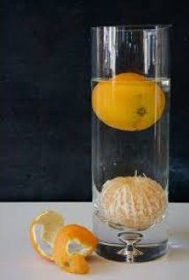  Oren dengan kulit terapung  Whole orange floats  Oren terkupas tenggelam  Peeled orange sinks  Rajah 10.2  Diagram 10.2  Dengan menggunakan Prinsip Archimedes, terangkan bagaimana situasi ini terjadi.  Using the Archimedes’ Principle, explain how this situation happened.  [4 markah]  [4 marks]

Bahagian C
Section C
[20 markah]
[20 marks]
Jawab semua soalan dalam bahagian ini.
Answer all questions in this section.

11 | Rajah 11.1 dan 11.2 menunjukkan biasan cahaya melalui dua medium yang berbeza ketumpatan. Indeks biasan medium X dan Y adalah masing-masing 1.51 dan 2.05 Diagram 11.1 and 11.2 show refraction of light through two mediums of different density. Refractive index of medium X and Y are 1.51 and 2.05 respectively.  Rajah 11.1  Diagram 11.1  sinar tuju  incident ray  garis normal  normal line  60 ⁰  35 ⁰  60 ⁰  Medium X  Medium Y  sinar biasan  refracted ray  25 ⁰  Rajah 11.2  Diagram 11.2
 | (a) | Apakah maksud biasan?  What is the meaning of refraction?  [1 markah]  [1 mark]
 | (b) | Berdasarkan Rajah 11.1 dan 11.2,  Based on Diagram 11.1 and 11.2  (i) bandingkan sudut tuju, sudut biasan dan Indeks biasan antara medium X dan medium Y.  compare the incident angle,,the refracted angle and the refractive index  between medium X and medium Y.  (ii) hubungkaitkan antara sudut biasan dengan indeks biasan untuk membuat kesimpulan tentang hubungan antara indeks biasan dengan ketumpatan medium.  Relate the refracted angle with the refractive index to make a deduction on the relationship between refractive index and the density of the medium.  [5 markah]  [5 marks]
 | (c) | Rajah 11.3 menunjukkan struktur sebuah pemantul belakang sebuah basikal  yang direka oleh pelajar. Pemantul itu terdiri daripada satu prisma dengan sudut genting 42º  Diagram 11.3 shows the structure of a rear reflector of a bicycle created by student.The reflector consists of a prism which have critical angle 42º.  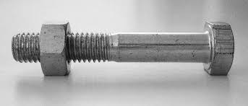  Penutup  cover  Prisma  Prism  Sinar tuju  Incident ray  Rajah 11.3  Diagram 11.3  Anda dikehendaki untuk mencadangkan ciri-ciri yang sesuai supaya pemantul itu dapat digunakan untuk memantulkan cahaya dengan keamatan yang tinggi.  Nyata dan terangkan cadangan anda berdasarkan aspek-aspek berikut:  You are assigned to give suggestions on the characteristic of the reflector so that it can be used to reflect high intensity of light.  State and explain your suggestion based on the following aspects.  (i) sudut prisma yang digunakan.  angle of prism used  (ii) bahan prisma  material of the prism  (iii) ciri pada penutup  characteristic of the cover  (iv) bilangan prisma  number of prism  (v) kedudukan pemantul  position of the reflector  [10 markah]  [10 marks]
 | (d) | Rajah 11.4 menunjukkan satu sinar cahaya merambat ke dalam intan.  Sudut genting intan adalah 24⁰. x adalah sudut tuju.  Diagram 11.4 shows a light ray passing into diamond.  Critical angle of diamond is 24⁰. x is the incident angle.  Sinar cahaya  Light ray  Intan  Diamond  x  B  Rajah 11.4  Diagram 11.4  Terangkan apakah yang akan berlaku kepada sinar cahaya itu pada titik B jika  Explain what will happen to the light ray at point B if  (i) x = 20⁰  (ii) x = 30⁰  [4 markah]  [4 marks]

END OF QUESTION PAPER
KERTAS PEPERIKSAAN TAMAT

